Hohan Soken

The Life of a Grand Master

Grand Master Hohan Soken (1889-1982) was born on May 25, 1889, and was the founder of the Matsumura Seito (Orthodox) style of Okinawan Shorin Ryu Karate. He was born in Gaja Village, Nishihara City, Okinawa Prefecture. According to Master Soken, in an interview, conducted on September 10, 1978, his style is derived from Bushi or Warrior Matsumura (1809-1889).
Bushi Matsumura was one of the most renowned martial artists of his time. King Sho Tai gave him the title “Bushi” meaning warrior, in recognition of his abilities and accomplishments in the martial arts. He eventually became the chief martial arts instructor and bodyguard of the Okinawan King.
According to Hohan Soken Sensei, Matsumura Orthodox is not the only authentic Shorin Ryu style. Bushi Matsumura had more than a dozen dedicated students. Each one learned his methods and expanded on them. However, Matsumura autudi or the Matsumura family lineage of Shorin Ryu was passed on from Matsumura Sensei to Nabe Matsumura his grandson who lived from (1850-1920).
Master Soken began training in karate at age thirteen in 1902 under his uncle Nabe Matsumura. According to Hohan Soken, “When Bushi Matsumura died he left the hands of his teachings to my uncle, Nabe Matsumura, who was also known as Nabe Tanmei or old man Nabe.” “Tanmei is a title that means respected old man in Okinawa. Soken sensei had to work in the fields as a youth despite his samurai heritage. This was due to a political reorganization in the Ryukyu Islands and all of Japan as a result of the Meiji restoration. The reorganization did away with the age-old feudal system that existed in Okinawa for hundreds of years. The emperor Meiji instituted this change in 1871 and forced the daimyo (feudal lords) to give up their estates in favor of a geo-political organization based on the prefecture system. Therefore, young Soken received his martial arts training at night or early in the morning. All of his training was conducted secretly. According to Soken Sensei, “In the old days training was always done in secret so that others would not steal your techniques”.
Back then; a master of the martial arts did not have a large following of students. According to Soken sensei, “Ankoh Itosu (1830-1915) had less than a dozen students and he was one of the greatest teachers at the time. My uncle had only one student, and that was me.” Master Soken has also been quoted as saying, “According to my uncle he only learned from Bushi Matsumura and only taught me what he had learned. So it can be said that Matsumara Orthodox is an ‘old version’ with no modern influences or sport applications.”
After ten years of basic training under Nabe Matsumura, Soken began learning the secret techniques of the white crane or hakutsuru. This was in 1912 when he was twenty-three years old. According to Soken, this was a secret technique or training methodology that was confined to the Matsumura family.

Master Soken also trained for a while with Kenwa Mabuni (1889-1953) the founder of Shito Ryu Karate and Gokenki, a Chinese tea merchant living in Okinawa. Gokenki, Soken and Mabuni along with several other Okinawans all trained together as a group. Gokenki’s style was hakutsuru kenpo (white crane fist style) and he was from the Fukien coast of China. Master Soken also studied traditional weaponry under Komesu Ushi-no-Tanmei and later under Mantaka Tsuken. Tsuken is known for the bo form called Tsuken-bo, which was Soken sensei’s favorite weapons form. Tsuken is also pronounced Chikin in the Okinawan Hogan dialect. Master Soken also learned the sai, tuifa, kama nunchaku, kusarigama and suruchin.

In 1924 Hohan Soken moved to Buenos Aires, Argentina to find his fortune. He learned to speak Spanish fluently and worked as a photographer and later worked in the dry cleaning business. He taught a few students in Argentina and gave numerous demonstrations throughout the country. Master Soken then returned to Okinawa in 1952. At first he did not teach karate. But eventually, he began to teach a few family members and then opened up a small dojo. Master Soken initially called his karate by the Okinawan dialect or Hogan name Machimura Sui-de or in Japanese, Matsumura Shure-Te.
In 1956 he officially changed the name of his teachings to Matsumura Orthodox Shorin Ryu Karate-so. However, he still maintained and trained in the old ways. Because of this, he did not join the new organizations that were being formed at the time. Soken taught many Americans. However, his most senior Okinawan student was Fusei Kise. Soken Sensei taught other Okinawans such as Seiki Arakaki (c.1922-1987), Yuichi Kuda (1928-1999), Chojun Makabe, Isamu Teruya, Kosei Nishihira, etc.

The Matsumura Kata
The kata that Soken Sensei taught were pinan shodan, pinan nidan, naihanchi shodan, naihanchi nidan, patsai-sho and dai, chinto, gojushiho, kusanku, rohai ichi-ni-san, and the hakutsuru. According to Master Soken, “Hakutsuru is my favorite kata that I demonstrate-because it is easier to do. When I was young, the best kata was the kusanku. This is the Matsumura kusanku-the older version that is not done much now.”
Master Soken also commented that the most important Matsumura kata is the kusanku kata. According to Soken sensei, “ Sometimes we would practice the kusanku with kanzashi (hairpins) held in the hands-this was a common method of fighting. The hairpins were symbols of rank and many Okinawans carried them for decoration (to hold their top knots in place) and for protection. Therefore they were expedient as self-defense weapons.” A unique feature of the Matsumura Shorin Ryu style is the teaching of the white crane or hakutsuru kata, although white crane techniques are woven throughout most of the kata of the style and are especially evident in gojushiho and kusanku. However, the hakutsuru kata is one of those elusive and esoteric kata of karate. According to the Hohan Soken, the white crane style was learned by Bushi Matsumura while he was in China. He then brought the style back to Okinawa in the 1860’s. From then on, the system was a secret style only taught to immediate members of the Matsumura family. The white crane style was passed on from Bushi Matsumura to Nabe Matsumura, his grandson, and then to Hohan Soken, Nabe’s nephew (his sister’s son). Hohan Soken did teach the white crane to some members of the ryu. These people were not family members but were a chosen few. Keep in mind the concept of a hereditary ryu is a closed social nexus, like a family or a clan. It’s membership is restricted to blood relatives, whereas a ryu ha is a group that practices the same style but its members are not necessarily related. Usually anyone can get into this social group, like a bowling league or a ‘self-defense’ studio. The family blood lineage of Matsumura Shorin Ryu seems to have broken though. It is my understanding that Hohan Soken’s son was a ‘Sake Joe’ and his grandson now lives in New York City and has no interest in karate. The Matsumura white crane system is still in existence and being taught today, but is rare and still underground.
The hakutsuru technique manifests the Chinese concept of the soft fist as opposed to the power-orientated native Okinawan techniques. The soft fist is defensive and relies on speed and evasion as its primary tactic. Therefore, the Matsumura family style has both the power-orientated linear Okinawan technique as well as soft circular Chinese techniques. A perfect combination! Finally, there is the Matsumura no hakutsuru kata itself. The kata is taught in two forms, a sort of sho (minor) and dai (major) 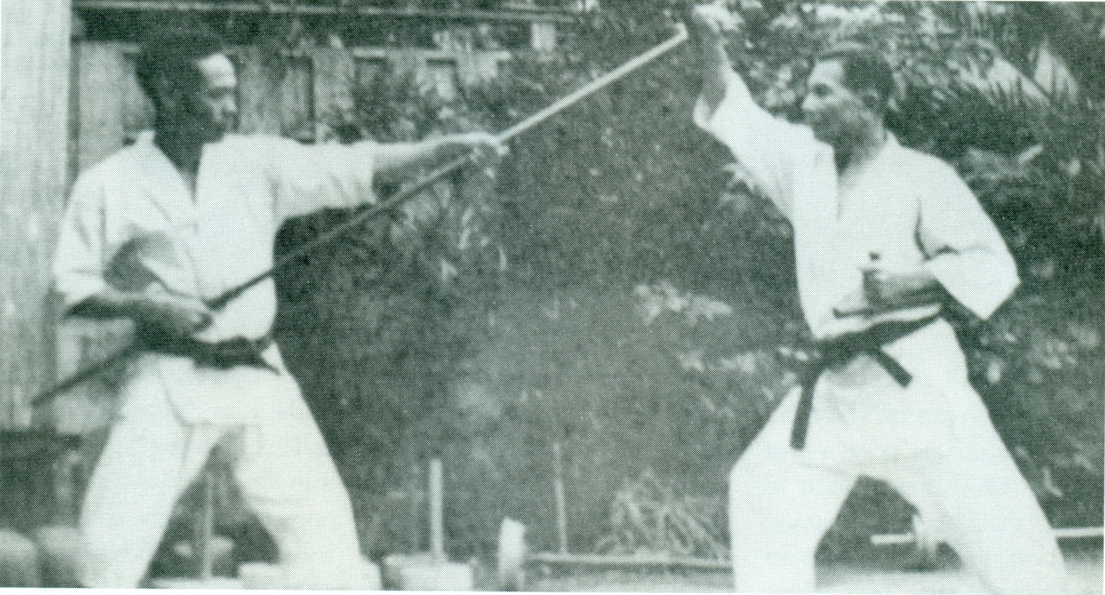format.
‘Bo’ versus ‘tongfa’, Eisuke Akamine (left) and Shinken Taira 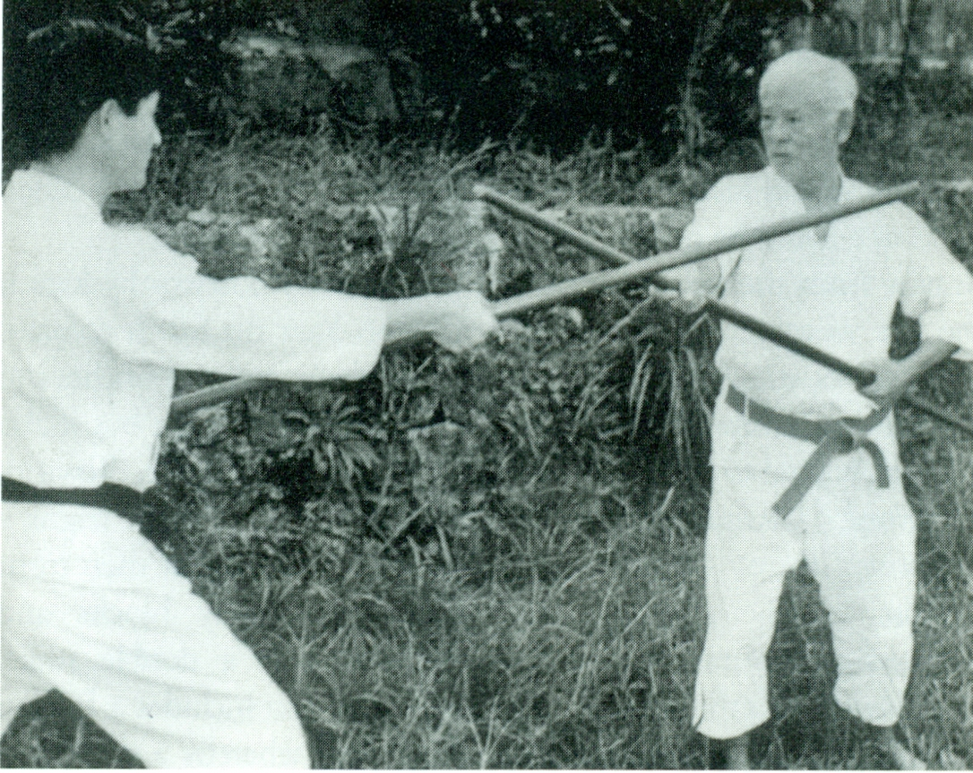

Hohan Soken (right) in ‘bo’ versus ‘bo’.

